# TUGAS 4

**BAHASA PEMROGRAMAN ASSEMBLY**



**Dosen Pengampu :**

**I Ketut Purnamawan, S.Kom., M.Kom.**

**Disusun Oleh :**

**I Gede Gelgel Abdiutama ; 2115101014**

**MATA KULIAH ARSITEKTUR DAN ORGANISASI KOMPUTER**

**UNIVERSITAS PENDIDIKAN GANESHA**

**SINGARAJA**

**TA. 2022**

1. **KEGIATAN BELAJAR**

**Percobaan 1**

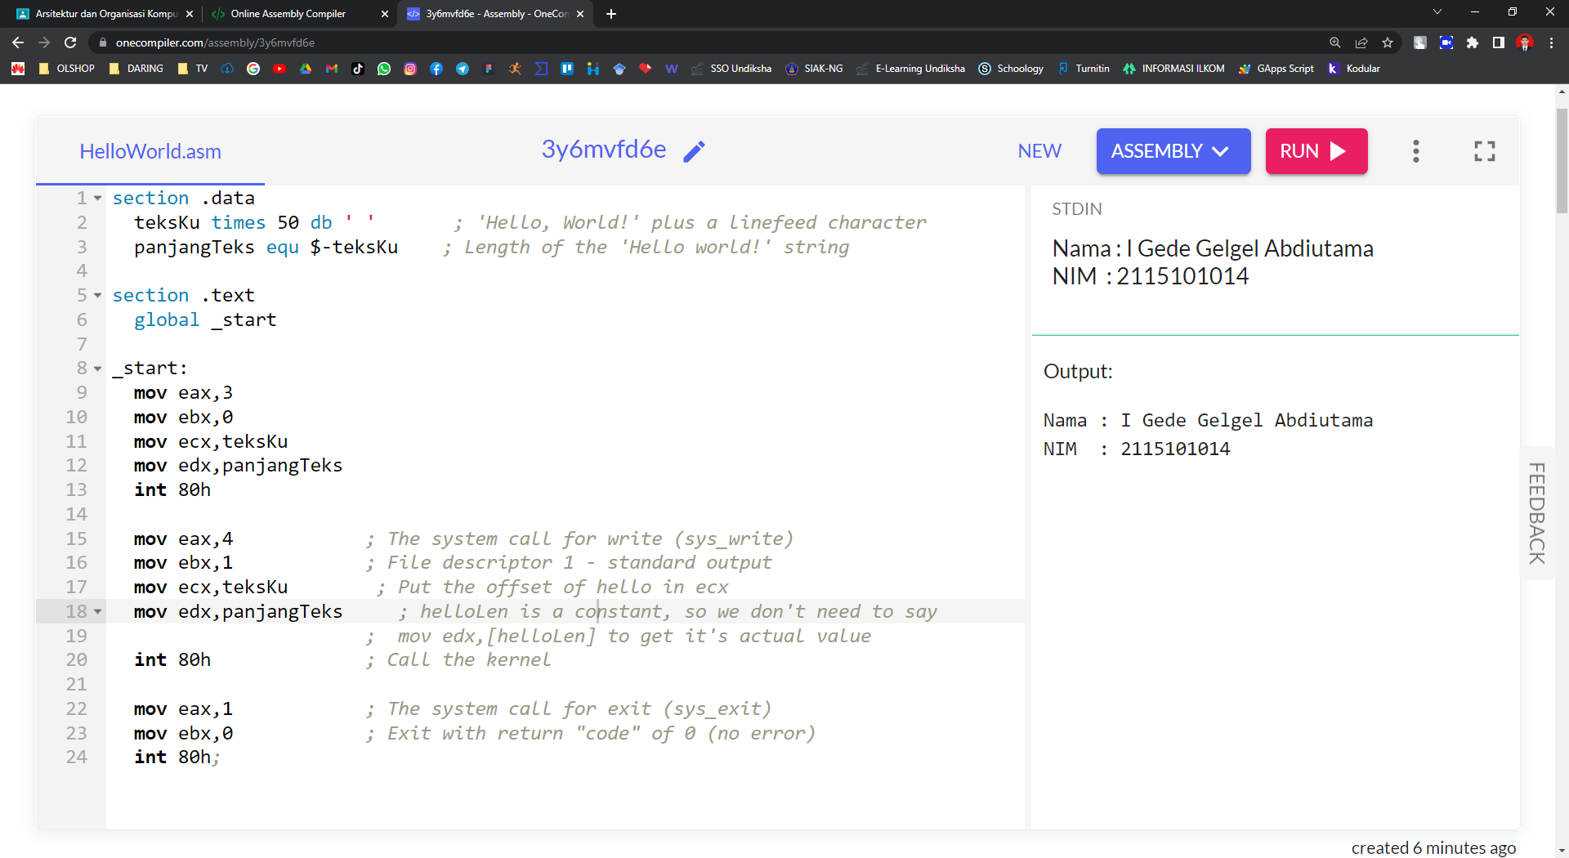

**Kode Program :**

section .data

teksKu times 50 db ' ' ; 'Hello, World!' plus a linefeed character

panjangTeks equ $-teksKu ; Length of the 'Hello world!' string

section .text

global _start

_start:

mov eax,3

mov ebx,0

mov ecx,teksKu

mov edx,panjangTeks

int 80h

mov eax,4 ; The system call for write (sys_write)

mov ebx,1 ; File descriptor 1 - standard output

mov ecx,teksKu ; Put the offset of hello in ecx

mov edx,panjangTeks ; helloLen is a constant, so we don't need to say

; mov edx,[helloLen] to get it's actual value

int 80h ; Call the kernel

mov eax,1 ; The system call for exit (sys_exit)

mov ebx,0 ; Exit with return "code" of 0 (no error)

int 80h;

**Percobaan 2**

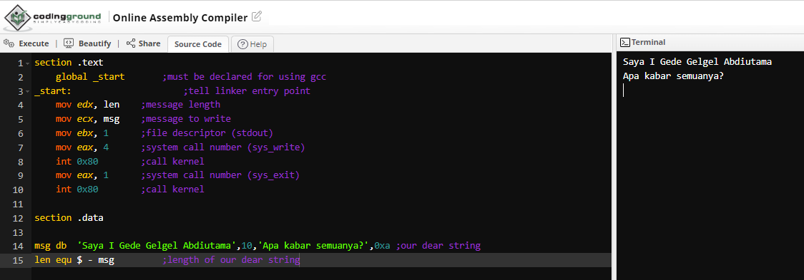

**Kode Program :**

section .text

global _start ;must be declared for using gcc

_start: ;tell linker entry point

mov edx, len ;message length

mov ecx, msg ;message to write

mov ebx, 1 ;file descriptor (stdout)

mov eax, 4 ;system call number (sys_write)

int 0x80 ;call kernel

mov eax, 1 ;system call number (sys_exit)

int 0x80 ;call kernel

section .data

msg db 'Saya I Gede Gelgel Abdiutama',10,'Apa kabar semuanya?',0xa ;our dear string

len equ $ - msg ;length of our dear string